**Final analysis: Multispecies camera data**

**Response data: 2011-2014 (3 years of data)**

**Independent data: 2010 ABMI human footprint, 2012 linear features, reclassified AVI**

**##Based on what I did for white-tailed deer analysis in 2015.**

AVI RECLASS SCHEME

1. Upland deciduous: (Aw, Pb, Bw >=70% canopy), moisture = d or m

2. Lowland deciduous: (Aw, Pb, birch >=70% canopy), moisture = w or a

3. Upland mixedwood: (40% -60%) canopy, moisture = d or m

4. Lowland mixedwood: (40% -60%) canopy, moisture = w or a

5. Upland spruce: (Sb, Sw, Fb >=70% canopy), moisture = d or m

6. Lowland spruce: (Sb,Sw,Fb >=70% canopy), moisture = w or a

7. Pine: All Pj (>=70%)

8. Tamarack: All Lt (>=70%)

9. Open wetland: <6% crown closure; w or a

10. Upland shrubs: >25% shrub cover; <6% tree cover; moisture = d or m

11. Water: standing or flowing water

12. Cutblocks: (from HF layer)

13. Nonforest: <6% canopy

14. Human Use (human habitat, industrial and resource extraction features, linear features (pipelines, cut-lines, roads, rail)) (from HF layer)

Where:

Aw = aspen, Pb = poplar, Bw = white birch, Sb = black spruce Sw = white spruce, Fb = balsam fir, Pj = jack pine, Lt = tamarack/larch; d = dry, m = mesic, w = wet, a = aquatic

**###load in landscape data**

deer250hab = read.table("C:\\Rtemp\\deer250hab.txt", header=T)

deer500hab = read.table("C:\\Rtemp\\deer500hab.txt", header=T)

deer750hab = read.table("C:\\Rtemp\\deer750hab.txt", header=T)

deer1000hab = read.table("C:\\Rtemp\\deer1000hab.txt", header=T)

deer1250hab = read.table("C:\\Rtemp\\deer1250hab.txt", header=T)

deer1500hab = read.table("C:\\Rtemp\\deer1500hab.txt", header=T)

deer1750hab = read.table("C:\\Rtemp\\deer1750hab.txt", header=T)

deer2000hab = read.table("C:\\Rtemp\\deer2000hab.txt", header=T)

deer2250hab = read.table("C:\\Rtemp\\deer2250hab.txt", header=T)

deer2500hab = read.table("C:\\Rtemp\\deer2500hab.txt", header=T)

deer2750hab = read.table("C:\\Rtemp\\deer2750hab.txt", header=T)

deer3000hab = read.table("C:\\Rtemp\\deer3000hab.txt", header=T)

deer3250hab = read.table("C:\\Rtemp\\deer3250hab.txt", header=T)

deer3500hab = read.table("C:\\Rtemp\\deer3500hab.txt", header=T)

deer3750hab = read.table("C:\\Rtemp\\deer3750hab.txt", header=T)

deer4000hab = read.table("C:\\Rtemp\\deer4000hab.txt", header=T)

deer4250hab = read.table("C:\\Rtemp\\deer4250hab.txt", header=T)

deer4500hab = read.table("C:\\Rtemp\\deer4500hab.txt", header=T)

deer4750hab = read.table("C:\\Rtemp\\deer4750hab.txt", header=T)

deer5000hab = read.table("C:\\Rtemp\\deer5000hab.txt", header=T)

deer250linear = read.table("C:\\Rtemp\\deer250linear.txt", header=T)

deer500linear = read.table("C:\\Rtemp\\deer500linear.txt", header=T)

deer750linear = read.table("C:\\Rtemp\\deer750linear.txt", header=T)

deer1000linear = read.table("C:\\Rtemp\\deer1000linear.txt", header=T)

deer1250linear = read.table("C:\\Rtemp\\deer1250linear.txt", header=T)

deer1500linear = read.table("C:\\Rtemp\\deer1500linear.txt", header=T)

deer1750linear = read.table("C:\\Rtemp\\deer1750linear.txt", header=T)

deer2000linear = read.table("C:\\Rtemp\\deer2000linear.txt", header=T)

deer2250linear = read.table("C:\\Rtemp\\deer2250linear.txt", header=T)

deer2500linear = read.table("C:\\Rtemp\\deer2500linear.txt", header=T)

deer2750linear = read.table("C:\\Rtemp\\deer2750linear.txt", header=T)

deer3000linear = read.table("C:\\Rtemp\\deer3000linear.txt", header=T)

deer3250linear = read.table("C:\\Rtemp\\deer3250linear.txt", header=T)

deer3500linear = read.table("C:\\Rtemp\\deer3500linear.txt", header=T)

deer3750linear = read.table("C:\\Rtemp\\deer3750linear.txt", header=T)

deer4000linear = read.table("C:\\Rtemp\\deer4000linear.txt", header=T)

deer4250linear = read.table("C:\\Rtemp\\deer4250linear.txt", header=T)

deer4500linear = read.table("C:\\Rtemp\\deer4500linear.txt", header=T)

deer4750linear = read.table("C:\\Rtemp\\deer4750linear.txt", header=T)

deer5000linear = read.table("C:\\Rtemp\\deer5000linear.txt", header=T)

deer250HF = read.table("C:\\Rtemp\\deer250HF.txt", header=T)

deer500HF = read.table("C:\\Rtemp\\deer500HF.txt", header=T)

deer750HF = read.table("C:\\Rtemp\\deer750HF.txt", header=T)

deer1000HF = read.table("C:\\Rtemp\\deer1000HF.txt", header=T)

deer1250HF = read.table("C:\\Rtemp\\deer1250HF.txt", header=T)

deer1500HF = read.table("C:\\Rtemp\\deer1500HF.txt", header=T)

deer1750HF = read.table("C:\\Rtemp\\deer1750HF.txt", header=T)

deer2000HF = read.table("C:\\Rtemp\\deer2000HF.txt", header=T)

deer2250HF = read.table("C:\\Rtemp\\deer2250HF.txt", header=T)

deer2500HF = read.table("C:\\Rtemp\\deer2500HF.txt", header=T)

deer2750HF = read.table("C:\\Rtemp\\deer2750HF.txt", header=T)

deer3000HF = read.table("C:\\Rtemp\\deer3000HF.txt", header=T)

deer3250HF = read.table("C:\\Rtemp\\deer3250HF.txt", header=T)

deer3500HF = read.table("C:\\Rtemp\\deer3500HF.txt", header=T)

deer3750HF = read.table("C:\\Rtemp\\deer3750HF.txt", header=T)

deer4000HF = read.table("C:\\Rtemp\\deer4000HF.txt", header=T)

deer4250HF = read.table("C:\\Rtemp\\deer4250HF.txt", header=T)

deer4500HF = read.table("C:\\Rtemp\\deer4500HF.txt", header=T)

deer4750HF = read.table("C:\\Rtemp\\deer4750HF.txt", header=T)

deer5000HF = read.table("C:\\Rtemp\\deer5000HF.txt", header=T)

###Merge dataframes into a single dataframe for each scale

deer250 <- merge(deer250hab,deer250linear,by = "SiteNo")

deer250 <- merge(deer250,deer250HF,by = "SiteNo")

deer500 <- merge(deer500hab,deer500linear,by = "SiteNo")

deer500 <- merge(deer500,deer500HF,by = "SiteNo")

deer750 <- merge(deer750hab,deer750linear,by = "SiteNo")

deer750 <- merge(deer750,deer750HF,by = "SiteNo")

deer1000 <- merge(deer1000hab,deer1000linear,by = "SiteNo")

deer1000 <- merge(deer1000,deer1000HF,by = "SiteNo")

deer1250 <- merge(deer1250hab,deer1250linear,by = "SiteNo")

deer1250 <- merge(deer1250,deer1250HF,by = "SiteNo")

deer1500 <- merge(deer1500hab,deer1500linear,by = "SiteNo")

deer1500 <- merge(deer1500,deer1500HF,by = "SiteNo")

deer1750 <- merge(deer1750hab,deer1750linear,by = "SiteNo")

deer1750 <- merge(deer1750,deer1750HF,by = "SiteNo")

deer2000 <- merge(deer2000hab,deer2000linear,by = "SiteNo")

deer2000 <- merge(deer2000,deer2000HF,by = "SiteNo")

deer2250 <- merge(deer2250hab,deer2250linear,by = "SiteNo")

deer2250 <- merge(deer2250,deer2250HF,by = "SiteNo")

deer2500 <- merge(deer2500hab,deer2500linear,by = "SiteNo")

deer2500 <- merge(deer2500,deer2500HF,by = "SiteNo")

deer2750 <- merge(deer2750hab,deer2750linear,by = "SiteNo")

deer2750 <- merge(deer2750,deer2750HF,by = "SiteNo")

deer3000 <- merge(deer3000hab,deer3000linear,by = "SiteNo")

deer3000 <- merge(deer3000,deer3000HF,by = "SiteNo")

deer3250 <- merge(deer3250hab,deer3250linear,by = "SiteNo")

deer3250 <- merge(deer3250,deer3250HF,by = "SiteNo")

deer3500 <- merge(deer3500hab,deer3500linear,by = "SiteNo")

deer3500 <- merge(deer3500,deer3500HF,by = "SiteNo")

deer3750 <- merge(deer3750hab,deer3750linear,by = "SiteNo")

deer3750 <- merge(deer3750,deer3750HF,by = "SiteNo")

deer4000 <- merge(deer4000hab,deer4000linear,by = "SiteNo")

deer4000 <- merge(deer4000,deer4000HF,by = "SiteNo")

deer4250 <- merge(deer4250hab,deer4250linear,by = "SiteNo")

deer4250 <- merge(deer4250,deer4250HF,by = "SiteNo")

deer4500 <- merge(deer4500hab,deer4500linear,by = "SiteNo")

deer4500 <- merge(deer4500,deer4500HF,by = "SiteNo")

deer4750 <- merge(deer4750hab,deer4750linear,by = "SiteNo")

deer4750 <- merge(deer4750,deer4750HF,by = "SiteNo")

deer5000 <- merge(deer5000hab,deer5000linear,by = "SiteNo")

deer5000 <- merge(deer5000,deer5000HF,by = "SiteNo")

###note PercentPipeline.x = 2012 linear features layer; PercentPipeline.y = 2010 ABMI Human footprint layer. Correlation is high between these two.

###note Percentcutline = 2012 linear features layer; PercentSeismicline = 2010 ABMI HF layer. We used the 2012 cutline data going forward.

**Group scarce variables together into single variables**

deer250$Blockfeatures = deer250$PercentBorrow.Pits.Dugouts.Sumps + deer250$PercentIndustrialSiteRural + deer250$PercentOtherDisturbedVegetation

deer500$Blockfeatures = deer500$PercentBorrow.Pits.Dugouts.Sumps + deer500$PercentIndustrialSiteRural + deer500$PercentOtherDisturbedVegetation

deer750$Blockfeatures = deer750$PercentBorrow.Pits.Dugouts.Sumps + deer750$PercentIndustrialSiteRural + deer750$PercentOtherDisturbedVegetation

deer1000$Blockfeatures = deer1000$PercentBorrow.Pits.Dugouts.Sumps + deer1000$PercentIndustrialSiteRural + deer1000$PercentOtherDisturbedVegetation

deer1250$Blockfeatures = deer1250$PercentBorrow.Pits.Dugouts.Sumps + deer1250$PercentIndustrialSiteRural + deer1250$PercentOtherDisturbedVegetation

deer1500$Blockfeatures = deer1500$PercentBorrow.Pits.Dugouts.Sumps + deer1500$PercentIndustrialSiteRural + deer1500$PercentOtherDisturbedVegetation

deer1750$Blockfeatures = deer1750$PercentBorrow.Pits.Dugouts.Sumps + deer1750$PercentIndustrialSiteRural + deer1750$PercentOtherDisturbedVegetation

deer2000$Blockfeatures = deer2000$PercentBorrow.Pits.Dugouts.Sumps + deer2000$PercentIndustrialSiteRural + deer2000$PercentOtherDisturbedVegetation

deer2250$Blockfeatures = deer2250$PercentBorrow.Pits.Dugouts.Sumps + deer2250$PercentIndustrialSiteRural + deer2250$PercentOtherDisturbedVegetation

deer2500$Blockfeatures = deer2500$PercentBorrow.Pits.Dugouts.Sumps + deer2500$PercentIndustrialSiteRural + deer2500$PercentOtherDisturbedVegetation

deer2750$Blockfeatures = deer2750$PercentBorrow.Pits.Dugouts.Sumps + deer2750$PercentIndustrialSiteRural + deer2750$PercentOtherDisturbedVegetation

deer3000$Blockfeatures = deer3000$PercentBorrow.Pits.Dugouts.Sumps + deer3000$PercentIndustrialSiteRural + deer3000$PercentOtherDisturbedVegetation

deer3250$Blockfeatures = deer3250$PercentBorrow.Pits.Dugouts.Sumps + deer3250$PercentIndustrialSiteRural + deer3250$PercentOtherDisturbedVegetation

deer3500$Blockfeatures = deer3500$PercentBorrow.Pits.Dugouts.Sumps + deer3500$PercentIndustrialSiteRural + deer3500$PercentOtherDisturbedVegetation

deer3750$Blockfeatures = deer3750$PercentBorrow.Pits.Dugouts.Sumps + deer3750$PercentIndustrialSiteRural + deer3750$PercentOtherDisturbedVegetation

deer4000$Blockfeatures = deer4000$PercentBorrow.Pits.Dugouts.Sumps + deer4000$PercentIndustrialSiteRural + deer4000$PercentOtherDisturbedVegetation

deer4250$Blockfeatures = deer4250$PercentBorrow.Pits.Dugouts.Sumps + deer4250$PercentIndustrialSiteRural + deer4250$PercentOtherDisturbedVegetation

deer4500$Blockfeatures = deer4500$PercentBorrow.Pits.Dugouts.Sumps + deer4500$PercentIndustrialSiteRural + deer4500$PercentOtherDisturbedVegetation

deer4750$Blockfeatures = deer4750$PercentBorrow.Pits.Dugouts.Sumps + deer4750$PercentIndustrialSiteRural + deer4750$PercentOtherDisturbedVegetation

deer5000$Blockfeatures = deer5000$PercentBorrow.Pits.Dugouts.Sumps + deer5000$PercentIndustrialSiteRural + deer5000$PercentOtherDisturbedVegetation

deer250$Allroads = deer250$PercentOneLaneGravel + deer250$PercentOneLanePaved + deer250$PercentTwoLaneGravel + deer250$PercentTwoLanePaved + deer250$PercentUnimprovedRoad

deer250$Alltrails = deer250$PercentTrail + deer250$PercentTruckTrail

deer500$Allroads = deer500$PercentOneLaneGravel + deer500$PercentOneLanePaved + deer500$PercentTwoLaneGravel + deer500$PercentTwoLanePaved + deer500$PercentUnimprovedRoad

deer500$Alltrails = deer500$PercentTrail + deer500$PercentTruckTrail

deer750$Allroads = deer750$PercentOneLaneGravel + deer750$PercentOneLanePaved + deer750$PercentTwoLaneGravel + deer750$PercentTwoLanePaved + deer750$PercentUnimprovedRoad

deer750$Alltrails = deer750$PercentTrail + deer750$PercentTruckTrail

deer1000$Allroads = deer1000$PercentOneLaneGravel + deer1000$PercentOneLanePaved + deer1000$PercentTwoLaneGravel + deer1000$PercentTwoLanePaved + deer1000$PercentUnimprovedRoad

deer1000$Alltrails = deer1000$PercentTrail + deer1000$PercentTruckTrail

deer1250$Allroads = deer1250$PercentOneLaneGravel + deer1250$PercentOneLanePaved + deer1250$PercentTwoLaneGravel + deer1250$PercentTwoLanePaved + deer1250$PercentUnimprovedRoad

deer1250$Alltrails = deer1250$PercentTrail + deer1250$PercentTruckTrail

deer1500$Allroads = deer1500$PercentOneLaneGravel + deer1500$PercentOneLanePaved + deer1500$PercentTwoLaneGravel + deer1500$PercentTwoLanePaved + deer1500$PercentUnimprovedRoad

deer1500$Alltrails = deer1500$PercentTrail + deer1500$PercentTruckTrail

deer1750$Allroads = deer1750$PercentOneLaneGravel + deer1750$PercentOneLanePaved + deer1750$PercentTwoLaneGravel + deer1750$PercentTwoLanePaved + deer1750$PercentUnimprovedRoad

deer1750$Alltrails = deer1750$PercentTrail + deer1750$PercentTruckTrail

deer2000$Allroads = deer2000$PercentOneLaneGravel + deer2000$PercentOneLanePaved + deer2000$PercentTwoLaneGravel + deer2000$PercentTwoLanePaved + deer2000$PercentUnimprovedRoad

deer2000$Alltrails = deer2000$PercentTrail + deer2000$PercentTruckTrail

deer2250$Allroads = deer2250$PercentOneLaneGravel + deer2250$PercentOneLanePaved + deer2250$PercentTwoLaneGravel + deer2250$PercentTwoLanePaved + deer2250$PercentUnimprovedRoad

deer2250$Alltrails = deer2250$PercentTrail + deer2250$PercentTruckTrail

deer2500$Allroads = deer2500$PercentOneLaneGravel + deer2500$PercentOneLanePaved + deer2500$PercentTwoLaneGravel + deer2500$PercentTwoLanePaved + deer2500$PercentUnimprovedRoad

deer2500$Alltrails = deer2500$PercentTrail + deer2500$PercentTruckTrail

deer2750$Allroads = deer2750$PercentOneLaneGravel + deer2750$PercentOneLanePaved + deer2750$PercentTwoLaneGravel + deer2750$PercentTwoLanePaved + deer2750$PercentUnimprovedRoad

deer2750$Alltrails = deer2750$PercentTrail + deer2750$PercentTruckTrail

deer3000$Allroads = deer3000$PercentOneLaneGravel + deer3000$PercentOneLanePaved + deer3000$PercentTwoLaneGravel + deer3000$PercentTwoLanePaved + deer3000$PercentUnimprovedRoad

deer3000$Alltrails = deer3000$PercentTrail + deer3000$PercentTruckTrail

deer3250$Allroads = deer3250$PercentOneLaneGravel + deer3250$PercentOneLanePaved + deer3250$PercentTwoLaneGravel + deer3250$PercentTwoLanePaved + deer3250$PercentUnimprovedRoad

deer3250$Alltrails = deer3250$PercentTrail + deer3250$PercentTruckTrail

deer3500$Allroads = deer3500$PercentOneLaneGravel + deer3500$PercentOneLanePaved + deer3500$PercentTwoLaneGravel + deer3500$PercentTwoLanePaved + deer3500$PercentUnimprovedRoad

deer3500$Alltrails = deer3500$PercentTrail + deer3500$PercentTruckTrail

deer3750$Allroads = deer3750$PercentOneLaneGravel + deer3750$PercentOneLanePaved + deer3750$PercentTwoLaneGravel + deer3750$PercentTwoLanePaved + deer3750$PercentUnimprovedRoad

deer3750$Alltrails = deer3750$PercentTrail + deer3750$PercentTruckTrail

deer4000$Allroads = deer4000$PercentOneLaneGravel + deer4000$PercentOneLanePaved + deer4000$PercentTwoLaneGravel + deer4000$PercentTwoLanePaved + deer4000$PercentUnimprovedRoad

deer4000$Alltrails = deer4000$PercentTrail + deer4000$PercentTruckTrail

deer4250$Allroads = deer4250$PercentOneLaneGravel + deer4250$PercentOneLanePaved + deer4250$PercentTwoLaneGravel + deer4250$PercentTwoLanePaved + deer4250$PercentUnimprovedRoad

deer4250$Alltrails = deer4250$PercentTrail + deer4250$PercentTruckTrail

deer4500$Allroads = deer4500$PercentOneLaneGravel + deer4500$PercentOneLanePaved + deer4500$PercentTwoLaneGravel + deer4500$PercentTwoLanePaved + deer4500$PercentUnimprovedRoad

deer4500$Alltrails = deer4500$PercentTrail + deer4500$PercentTruckTrail

deer4750$Allroads = deer4750$PercentOneLaneGravel + deer4750$PercentOneLanePaved + deer4750$PercentTwoLaneGravel + deer4750$PercentTwoLanePaved + deer4750$PercentUnimprovedRoad

deer4750$Alltrails = deer4750$PercentTrail + deer4750$PercentTruckTrail

deer5000$Allroads = deer5000$PercentOneLaneGravel + deer5000$PercentOneLanePaved + deer5000$PercentTwoLaneGravel + deer5000$PercentTwoLanePaved + deer5000$PercentUnimprovedRoad

deer5000$Alltrails = deer5000$PercentTrail + deer5000$PercentTruckTrail

**##Diagnostics: Landcover**

**##NOTE: This is re-examined from deer analysis.**

mylandcover = c("PercentHab1","PercentHab2", "PercentHab3", "PercentHab4","PercentHab5", "PercentHab6", "PercentHab7", "PercentHab8", "PercentHab9", "PercentHab10", "PercentHab11", "PercentHab13")

Mypairs(deer1000[,mylandcover])



###Results

Correlations >0.5:

1. Hab1,Hab7 (-0.61)

###omit Hab7 (pine) from global models, as this is not well represented in our study area and is highly correlated with a variable of interest and known importance (upland deciduous).

**DIAGNOSTICS: FOOTPRINT**

myfootprint = c("PercentCutBlocks","Percent3D", "PercentCutline","PercentPipeline.x","PercentWellSite", "Allroads", "Alltrails", "Blockfeatures")

Mypairs(deer1000[,myfootprint])



###Results

Correlations >0.5:

1. Cutblocks, 3D (-0.53)
2. Cutblocks, alltrails (0.60)

**###be careful interpreting these variables in global or combined models.**

mycovariates = c("PercentCutBlocks","Percent3D", "PercentCutline","PercentPipeline.x","PercentWellSite", "Allroads", "Blockfeatures","Alltrails","PercentHab1","PercentHab2", "PercentHab3", "PercentHab4","PercentHab5", "PercentHab6", "PercentHab7", "PercentHab8", "PercentHab9", "PercentHab10", "PercentHab11", "PercentHab13")

corvif(deer1000[,mycovariates])

###Results

Variance inflation factors

GVIF

PercentCutBlocks 3.966038e+00

Percent3D 2.299005e+00

PercentCutline 1.741842e+00

PercentPipeline.x 2.052873e+00

PercentWellSite 1.657160e+00

Allroads 2.230341e+00

Blockfeatures 1.884199e+00

Alltrails 2.249431e+00

PercentHab1 9.957032e+12

PercentHab2 5.495311e+09

PercentHab3 5.121586e+11

PercentHab4 4.790930e+11

PercentHab5 9.810970e+11

PercentHab6 5.952754e+12

PercentHab7 6.553257e+12

PercentHab8 1.716300e+12

PercentHab9 7.076174e+11

PercentHab10 7.215110e+10

PercentHab11 1.915796e+11

PercentHab13 8.481030e+11

###try again without Hab7 (as suggested by correlation matrix)or Hab13

mycovariates = c("PercentCutBlocks","Percent3D", "PercentCutline","PercentPipeline.x","PercentWellSite", "Allroads", "Blockfeatures","Alltrails","PercentHab1","PercentHab2", "PercentHab3", "PercentHab4","PercentHab5", "PercentHab6", "PercentHab8", "PercentHab9", "PercentHab10", "PercentHab11")

corvif(deer1000[,mycovariates])

###RESULTS

Variance inflation factors

GVIF

PercentCutBlocks 3.201077

Percent3D 2.234476

PercentCutline 1.622842

PercentPipeline.x 1.867485

PercentWellSite 1.628709

Allroads 2.087415

Blockfeatures 1.883369

Alltrails 2.222524

PercentHab1 2.759557

PercentHab2 1.587106

PercentHab3 1.805458

PercentHab4 1.237387

PercentHab5 1.421303

PercentHab6 2.794231

PercentHab8 1.643594

PercentHab9 2.305615

PercentHab10 1.412408

PercentHab11 1.256968

**###This set has low VIFs across the board so we'll use it in all subsequent models.**

**###Let's plot raw data**

CairoPNG(filename = "deer.landscape.data.PNG", width = 1500, height = 1500, pointsize = 12, bg = "white", res = 200)

par(mfrow=c(4,3))

hist(deer500$PercentHab1, main = "", xlab = "Upland deciduous", breaks = 20, col = "springgreen", border = "darkgreen")

hist(deer500$PercentHab2, main = "", xlab = "Lowland deciduous", breaks = 20, col = "springgreen", border = "darkgreen")

hist(deer500$PercentHab3, main = "", xlab = "Upland mixedwood", breaks = 20, col = "springgreen", border = "darkgreen")

hist(deer500$PercentHab4, main = "", xlab = "Lowland mixedwood", breaks = 20, col = "springgreen", border = "darkgreen")

hist(deer500$PercentHab5, main = "", xlab = "Upland spruce", breaks = 20, col = "springgreen", border = "darkgreen")

hist(deer500$PercentHab6, main = "", xlab = "Lowland spruce", breaks = 20, col = "springgreen", border = "darkgreen")

hist(deer500$PercentHab7, main = "", xlab = "Pine", breaks = 20, col = "springgreen", border = "darkgreen")

hist(deer500$PercentHab8, main = "", xlab = "Tamarack", breaks = 20, col = "springgreen", border = "darkgreen")

hist(deer500$PercentHab9, main = "", xlab = "Open wetland", breaks = 20, col = "springgreen", border = "darkgreen")

hist(deer500$PercentHab10, main = "", xlab = "Upland shrubs", breaks = 20, col = "springgreen", border = "darkgreen")

hist(deer500$PercentHab11, main = "", xlab = "Water", breaks = 20, col = "springgreen", border = "darkgreen")

hist(deer500$PercentHab13, main = "", xlab = "Nonforest", breaks = 20, col = "springgreen", border = "darkgreen")

dev.off()

CairoPNG(filename = "deer.anthro.data.PNG", width = 1500, height = 1500, pointsize = 12, bg = "white", res = 200)

par(mfrow=c(3,3))

hist(deer500$Percent3D, main = "", xlab = "3D Seismic lines", breaks = 20, col = "springgreen", border = "darkgreen")

hist(deer500$PercentCutline, main = "", xlab = "Seismic lines", breaks = 20, col = "springgreen", border = "darkgreen")

hist(deer500$PercentCutBlocks, main = "", xlab = "Forestry cutblocks", breaks = 20, col = "springgreen", border = "darkgreen")

hist(deer500$PercentPipeline.x, main = "", xlab = "Pipelines", breaks = 20, col = "springgreen", border = "darkgreen")

hist(deer500$PercentWellSite, main = "", xlab = "Well sites", breaks = 20, col = "springgreen", border = "darkgreen")

hist(deer500$Allroads, main = "", xlab = "Roads", breaks = 20, col = "springgreen", border = "darkgreen")

hist(deer500$Alltrails, main = "", xlab = "Trails", breaks = 20, col = "springgreen", border = "darkgreen")

hist(deer500$Blockfeatures, main = "", xlab = "Block features", breaks = 20, col = "springgreen", border = "darkgreen")

dev.off()

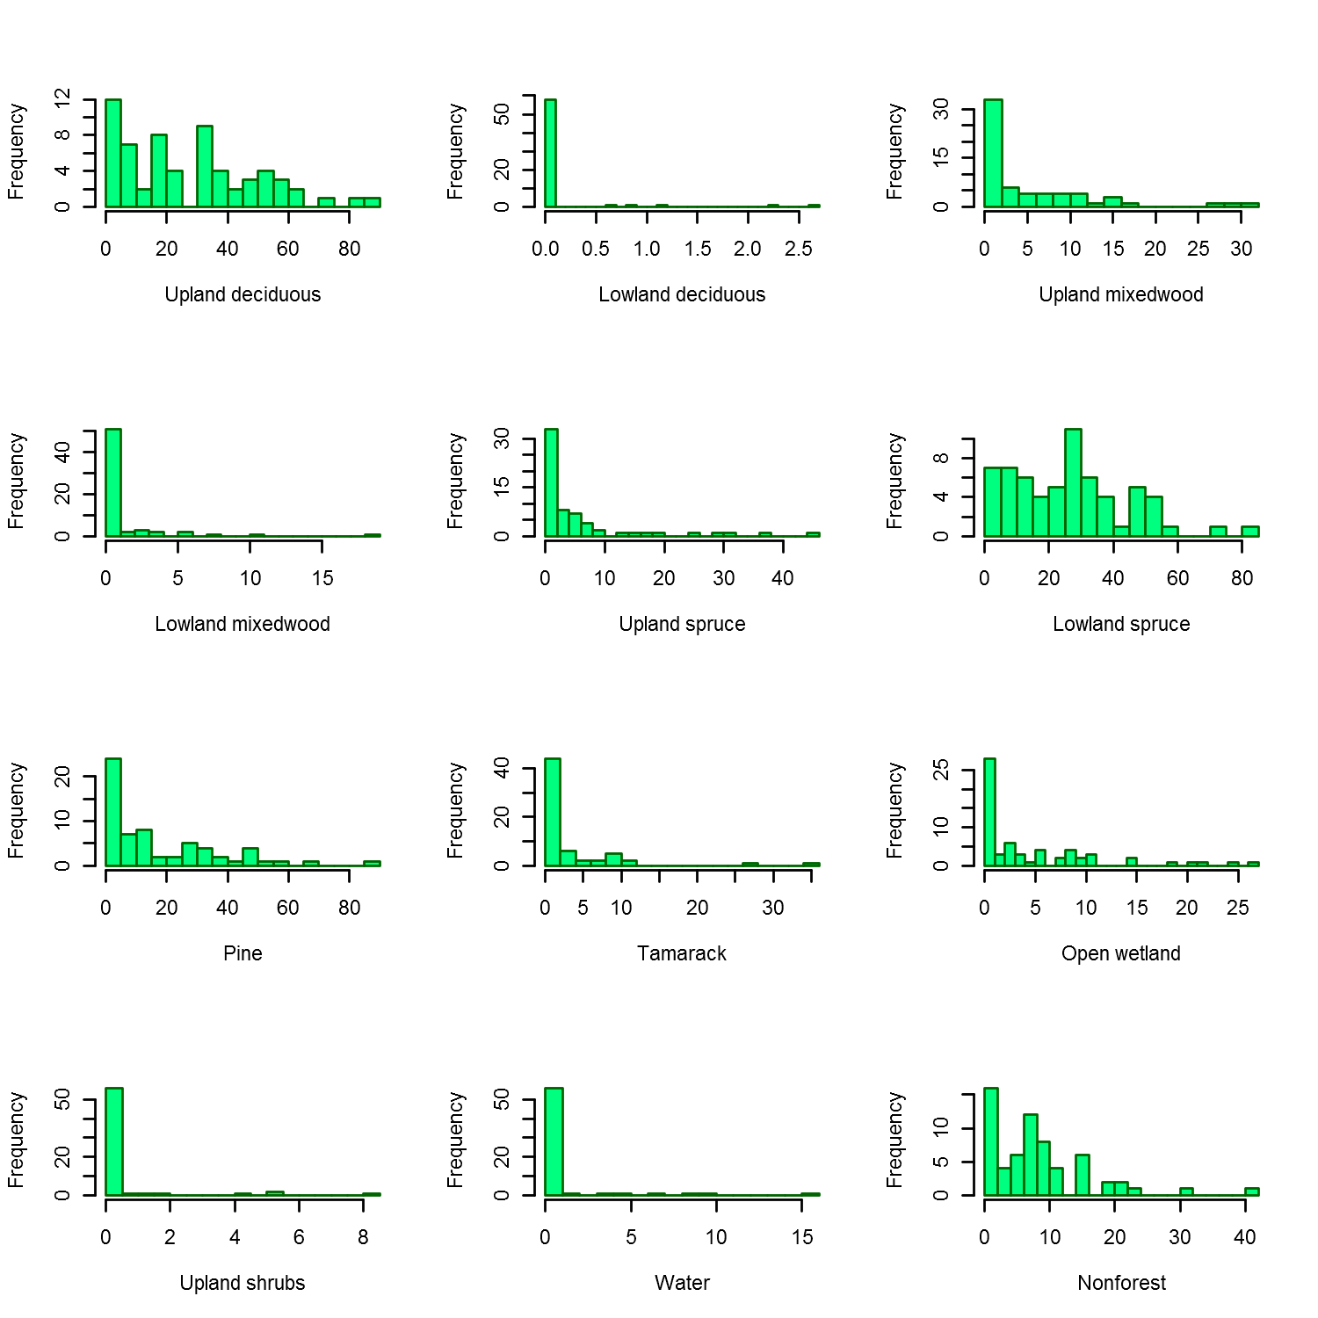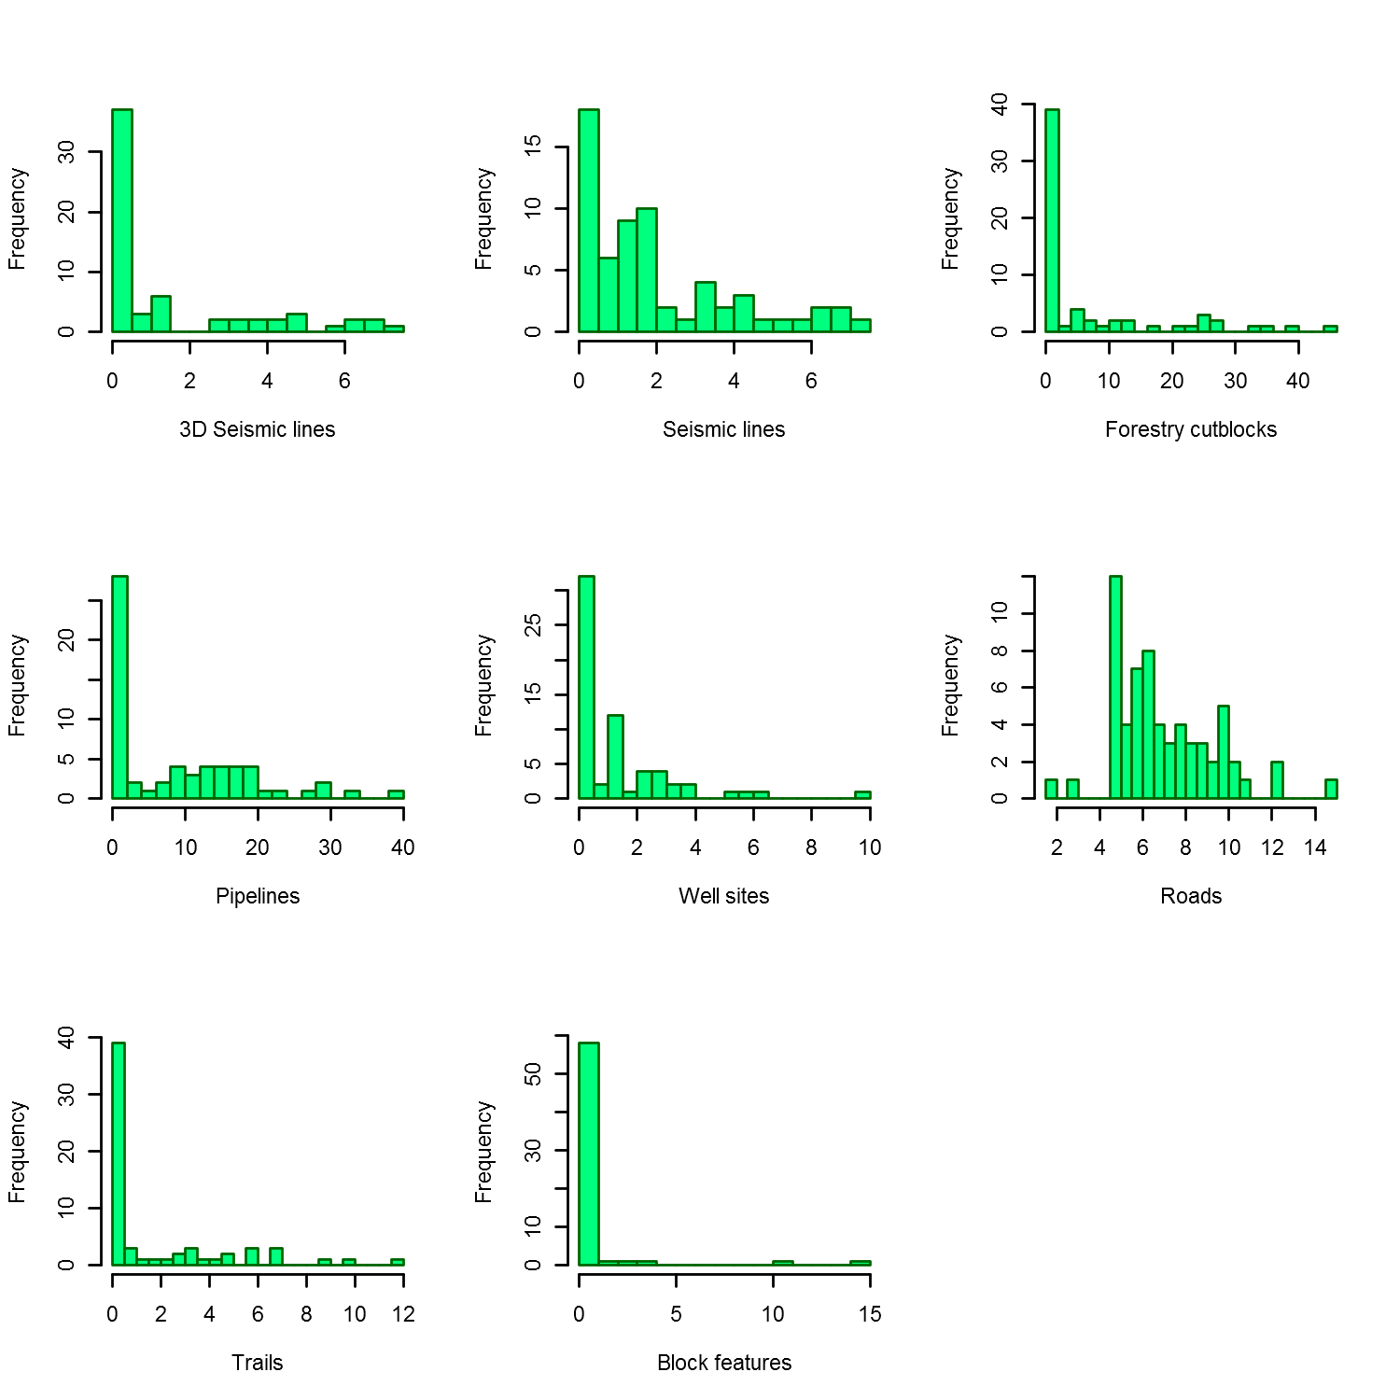

**Scale all covariates**

deer250$PercentHab1 = scale(deer250$PercentHab1)

deer250$PercentHab2 = scale(deer250$PercentHab2)

deer250$PercentHab3 = scale(deer250$PercentHab3)

deer250$PercentHab4 = scale(deer250$PercentHab4)

deer250$PercentHab5 = scale(deer250$PercentHab5)

deer250$PercentHab6 = scale(deer250$PercentHab6)

deer250$PercentHab7 = scale(deer250$PercentHab7)

deer250$PercentHab8 = scale(deer250$PercentHab8)

deer250$PercentHab9 = scale(deer250$PercentHab9)

deer250$PercentHab10 = scale(deer250$PercentHab10)

deer250$PercentHab11 = scale(deer250$PercentHab11)

deer250$PercentHab13 = scale(deer250$PercentHab13)

deer250$Percent3D = scale(deer250$Percent3D)

deer250$PercentCutline = scale(deer250$PercentCutline)

deer250$PercentCutBlocks = scale(deer250$PercentCutBlocks)

deer250$PercentPipeline.x = scale(deer250$PercentPipeline.x)

deer250$PercentWellSite = scale(deer250$PercentWellSite)

deer250$Allroads = scale(deer250$Allroads)

deer250$Alltrails = scale(deer250$Alltrails)

deer250$Blockfeatures = scale(deer250$Blockfeatures)

###Repeat for all other spatial scales (***used find and replace in editor***)

###check that all spatial scales were re-scaled

par(mfrow=c(5,4))

hist(deer250$Alltrails)

hist(deer500$Alltrails)

hist(deer750$Alltrails)

hist(deer1000$Alltrails)

hist(deer1250$Alltrails)

hist(deer1500$Alltrails)

hist(deer1750$Alltrails)

hist(deer2000$Alltrails)

hist(deer2250$Alltrails)

hist(deer2500$Alltrails)

hist(deer2750$Alltrails)

hist(deer3000$Alltrails)

hist(deer3250$Alltrails)

hist(deer3500$Alltrails)

hist(deer3750$Alltrails)

hist(deer4000$Alltrails)

hist(deer4250$Alltrails)

hist(deer4500$Alltrails)

hist(deer4750$Alltrails)

hist(deer5000$Alltrails)

###all looking good.

**Merge species data with GIS data**

species.months = read.table("C:\\Rtemp\\MultiSpeciesDataFinal.txt", header=T)

head(species.months)

###merge with dataframe of covariate data

deer250 <- merge(species.months,deer250,by="SiteNo")

##delete rogue sites 11 and 33

deer250 = deer250[-c(11,33), ]

###follow for rest of the scales

deer500 <- merge(species.months,deer500,by="SiteNo")

deer500 = deer500[-c(11,33), ]

deer750 <- merge(species.months,deer750,by="SiteNo")

deer750 = deer750[-c(11,33), ]

deer1000 <- merge(species.months,deer1000,by="SiteNo")

deer1000 = deer1000[-c(11,33), ]

deer1250 <- merge(species.months,deer1250,by="SiteNo")

deer1250 = deer1250[-c(11,33), ]

deer1500 <- merge(species.months,deer1500,by="SiteNo")

deer1500 = deer1500[-c(11,33), ]

deer1750 <- merge(species.months,deer1750,by="SiteNo")

deer1750 = deer1750[-c(11,33), ]

deer2000 <- merge(species.months,deer2000,by="SiteNo")

deer2000 = deer2000[-c(11,33), ]

deer2250 <- merge(species.months,deer2250,by="SiteNo")

deer2250 = deer2250[-c(11,33), ]

deer2500 <- merge(species.months,deer2500,by="SiteNo")

deer2500 = deer2500[-c(11,33), ]

deer2750 <- merge(species.months,deer2750,by="SiteNo")

deer2750 = deer2750[-c(11,33), ]

deer3000 <- merge(species.months,deer3000,by="SiteNo")

deer3000 = deer3000[-c(11,33), ]

deer3250 <- merge(species.months,deer3250,by="SiteNo")

deer3250 = deer3250[-c(11,33), ]

deer3500 <- merge(species.months,deer3500,by="SiteNo")

deer3500 = deer3500[-c(11,33), ]

deer3750 <- merge(species.months,deer3750,by="SiteNo")

deer3750 = deer3750[-c(11,33), ]

deer4000 <- merge(species.months,deer4000,by="SiteNo")

deer4000 = deer4000[-c(11,33), ]

deer4250 <- merge(species.months,deer4250,by="SiteNo")

deer4250 = deer4250[-c(11,33), ]

deer4500 <- merge(species.months,deer4500,by="SiteNo")

deer4500 = deer4500[-c(11,33), ]

deer4750 <- merge(species.months,deer4750,by="SiteNo")

deer4750 = deer4750[-c(11,33), ]

deer5000 <- merge(species.months,deer5000,by="SiteNo")

deer5000 = deer5000[-c(11,33), ]

##spotcheck some datasets – they check out. Time to model.